**Reg. No: 21BCE1297 Name: Vidhi Shah Date: 19/05/22**

**PPS15**

**Aim:**

**Q1:** Write a C++ program to create an employee database using class. Each employee should have name, emp_id and salary. Use getdata() and putdata() member functions to read and print the details of employees.

**Q2:** For the above database perform Linear searching and print a specific employee detail.

**Procedure:**

**Input:**

Number of employees, n

Employee details

Employee ID of employee whose specific employee detail is required

**Output:**

Employee details of the employee whose ID is entered

**Algorithm:**

**Class Employee:**

Step 1: Create a class Employee

Step 2: Add private data members: Name, ID and Salary

Step 3: Add public member function

1. **getdata():** Input user data for employee details
2. **putdata():** Output user data for employee details

Step 4: Add **Friend** member function

1. **linearSearch(int x, Employee array[]):** Find the details of employee having user input employee id

**Main Function:**

Step 1: Read number of employees n

Step 2: Create an Employee class array with n elements, database[n]

Step 3: Using for loop input data for all employees using ‘getdata’ function

Step 4: Input ID of employee whose details are required, x

Step 5: Call ‘linearSearch’ friend function with inputs as ‘x’ and ‘database’

Step 6: Return 0

**LinearSearch Friend Function:**

Step 1: Use for loop to iterate through each object in the array

Step 2: Compare employee ID of each object to the ID entered

Step 3: If IDs match then print the employee details using ‘putdata’ function

**Code:**

#include <iostream>

using namespace std;

int n;

class Employee {

    char name[30];

    int emp_id, salary;

    public:

    void getdata () {

        cout<<"\n\nEmployee ID: ";

        cin>>emp_id;

        cout<<"Employee Name: ";

        cin>>name;

        cout<<"Salary: ";

        cin>>salary;

    }

    void putdata () {

        cout<<"Employee ID: "<<emp_id<<"\n";

        cout<<"Employee Name: "<<name<<"\n";

        cout<<"Salary: "<<salary<<"\n";

    }

    friend void linearSearch (int x, Employee array[]);

};

int main() {

    int i, x;

    cout<<"Enter Number of Employees: ";

    cin>>n;

    Employee database[n];

    for (i = 0; i < n; i++) {

        database[i].getdata();

    }

    cout<<"\nEnter Employee ID to Search: ";

    cin>>x;

    linearSearch(x,database);

    return 0;

}

void linearSearch (int x, Employee array[]) {

    int i, id;

    for (i = 0; i < n; i++) {

        id = array[i].emp_id;

        if (x == id) {

            array[i].putdata();

        }

    }

}

**Output:**

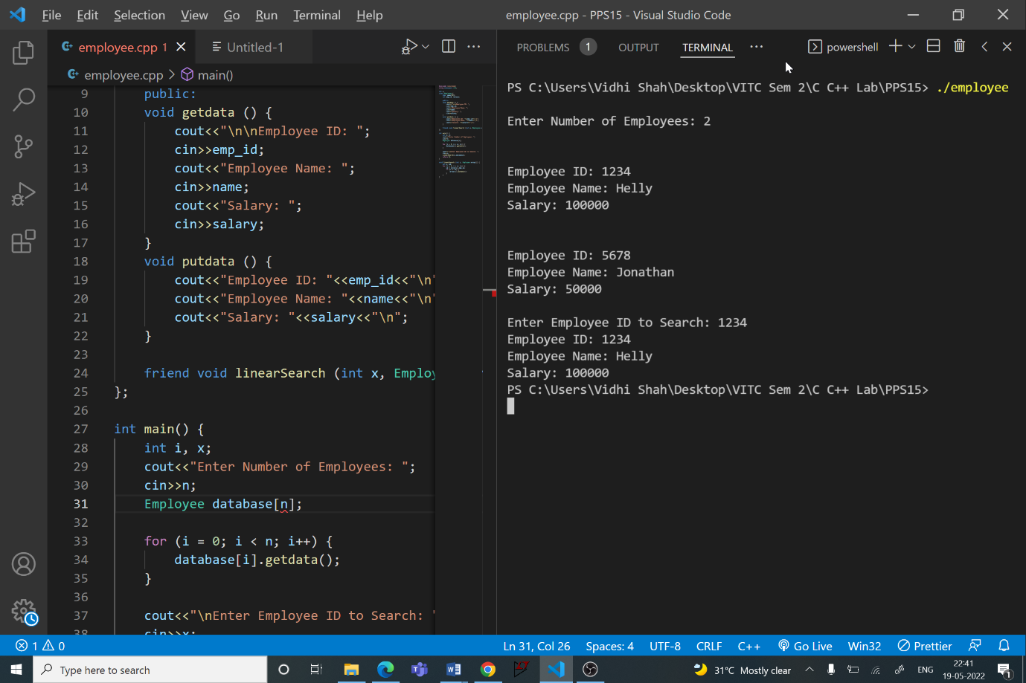

**Q3**

**Aim:**

Program to create a class ACCOUNTS with function read() to input sales and purchase details. Create a Friend function to print total tax to pay. Assume 4% of profit is tax.

**Procedure:**

**Input:**

Number of items, n

Purchase price for ‘n’ items

Sales price for ‘n’ items

**Output:**

Total tax

**Algorithm:**

**Class Accounts:**

Step 1: Create a class Accounts

Step 2: Add private data members: purchase, sales

Step 3: Add public member function

1. **read():**
   1. Enter number of items, n
   2. Using for loop enter purchase and sales price for n items

Step 4: Add **Friend** member function

1. **tax(Accounts object):** Calculate profit and tax

**Main Function:**

Step 1: Create an Accounts object, ‘company’

Step 2: Call read function

Step 3: Call ‘tax’ friend function with inputs as ‘company’

Step 4: Return 0

**Tax Friend Function:**

Step 1: profit = sales - purchase

Step 2: If profit > 0, then tax = 0.04 * profit, print tax

Step 3: Else print “Company in Loss”

**Code:**

#include <iostream>

using namespace std;

class Accounts {

    int purchase, sales;

    public:

    void read() {

        int i, n;

        cout<<"\nEnter Number of Items: ";

        cin>>n;

        int p[n], s[n];

        purchase = 0;

        cout<<"\nEnter Purchase Price of each Item: \n";

        for (i = 0; i < n; i++) {

            cout<<"Item "<<i+1<<": ";

            cin>>p[i];

            purchase += p[i];

        }

        sales = 0;

        cout<<"\nEnter Sales Price of each Item: \n";

        for (i = 0; i < n; i++) {

            cout<<"Item "<<i+1<<": ";

            cin>>s[i];

            sales += s[i];

        }

    }

    friend void tax (Accounts company);

};

int main() {

    Accounts company;

    company.read();

    tax(company);

    return 0;

}

void tax (Accounts company) {

    int profit;

    float tax;

    profit = company.sales - company.purchase;

    if (profit > 0) {

        tax = 0.04 * profit;

        cout<<"\nTotal Tax to Pay: "<<tax;

    }

    else {

        cout<<"Company in Loss";

    }

}

**Output:**

